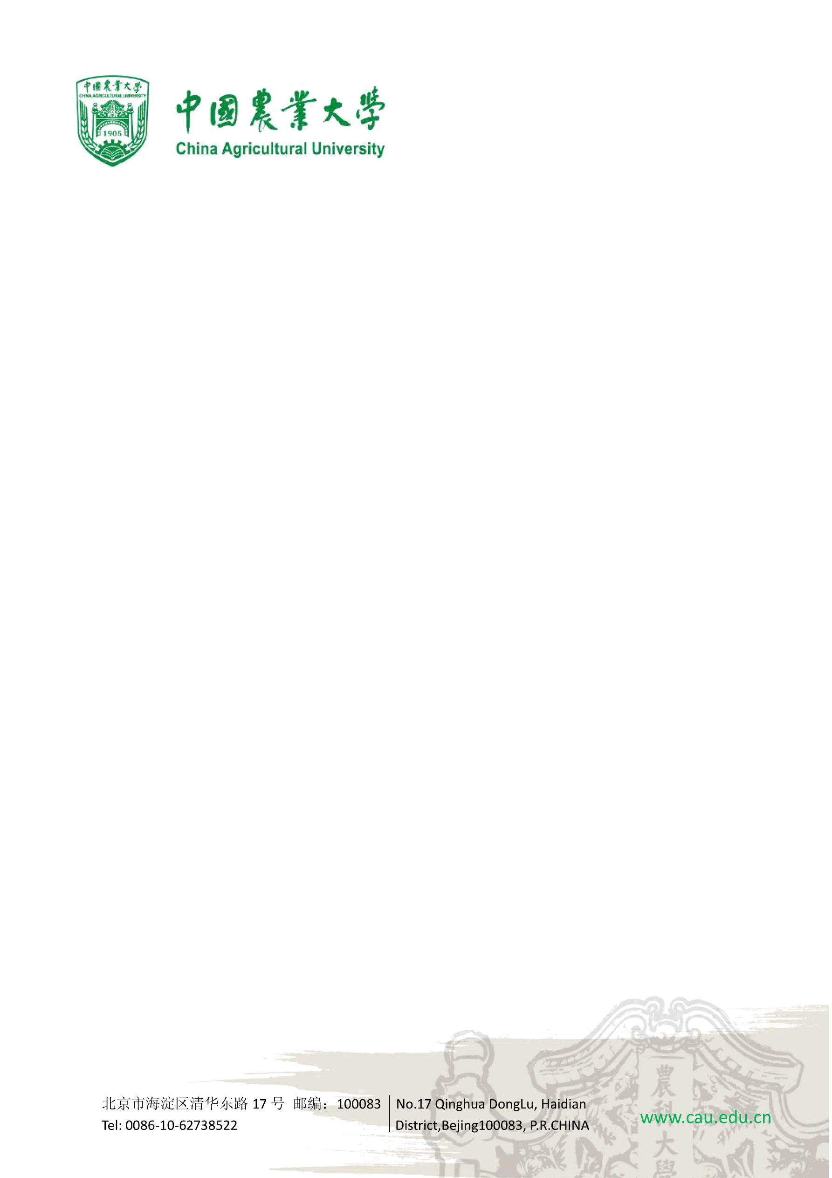

To, September 25, 2025
Dr. SHIRKOLE SHIVANAND SHANKARRAO
Associate Professor
D. Y. Patil Agriculture and Technical University
Talsande, Kolhapur-416112,
India

Subject: Oral presentation at the joint 12th Asia-Pacific Drying Conference (ADC) and & the 20th National Drying Conference

Dear Dr. SHIRKOLE SHIVANAND SHANKARRAO,
On behalf of the Organizing Committee of the 12th Asia-Pacific Drying Conference & the 20th National Drying Conference, it is our great pleasure to confirm that your paper has been accepted for oral presentation at our conference, which will be held from October 25-28, 2025, in Changzhou, China.
Your paper aligns perfectly with our conference theme, "Green intelligence promotes the development of new quality productivity in the drying industry." You can visit the website of the conference through https://adccdc2025.com/eindex.php .
Title of the Oral Presentation: Sustainability of industrial drying using renewable fuels.
The information as described below is for the purpose of your visa applications:
Name | Gender | DOB (y-m-d) | Passport No. | Title
SHIRKOLE  SHIVANAND  SHANKARRAO | Male | 1987-05-10 | Z6037663 | Associate Professor
We understand that all the costs for this visit will be supported by your university. Looking forward to meeting you in Changzhou this October.
